Ctrl+Click here to access the Membership Application
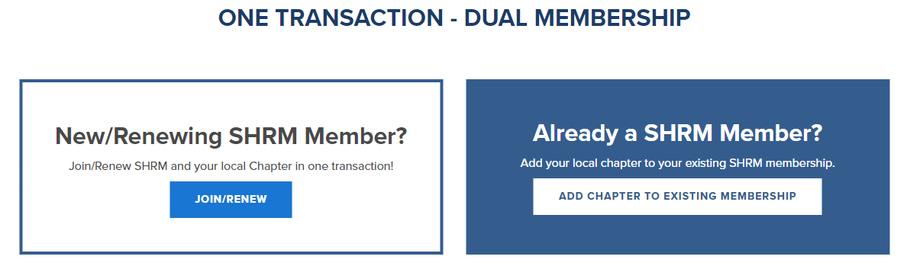

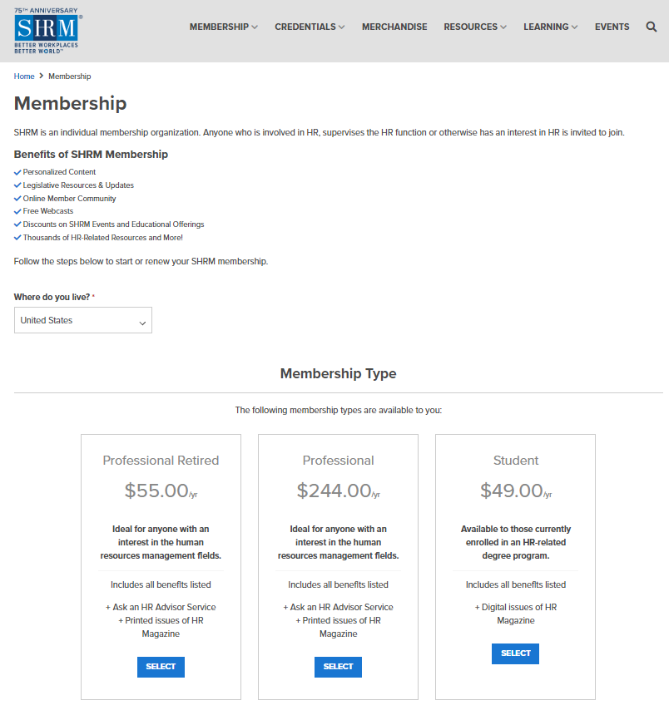
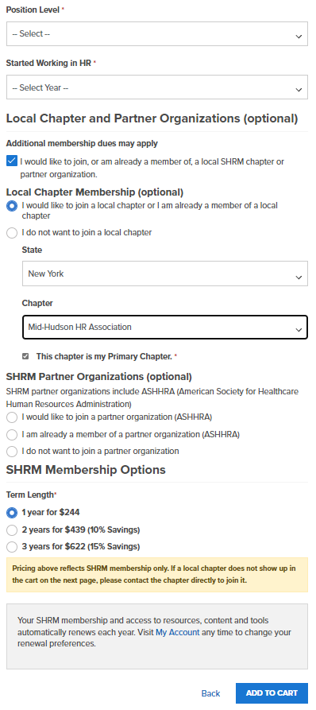
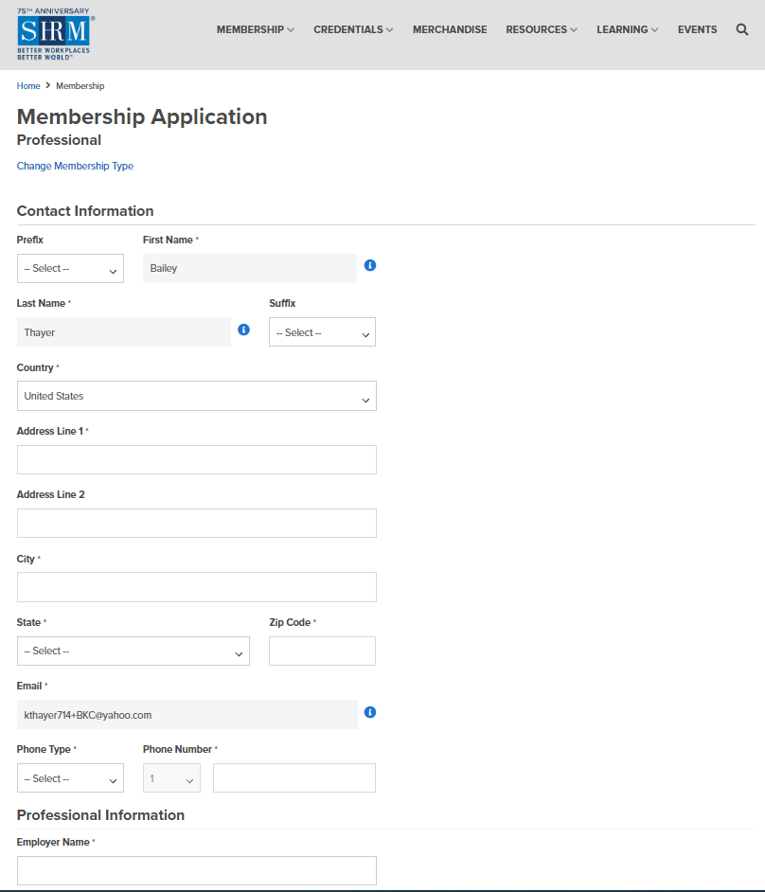
Click here to open the area below.
Pick
“Mid-Hudson HR Association”
Picking another chapter will not provide you with a FREE MHHRA membership.
This should be checked but if it isn’t, make sure to check it.

